**Name: Bisma Farhat**

**Sap-Id: 39967**

**Semester: BSCS-6**

**LAB 5**

Task1:

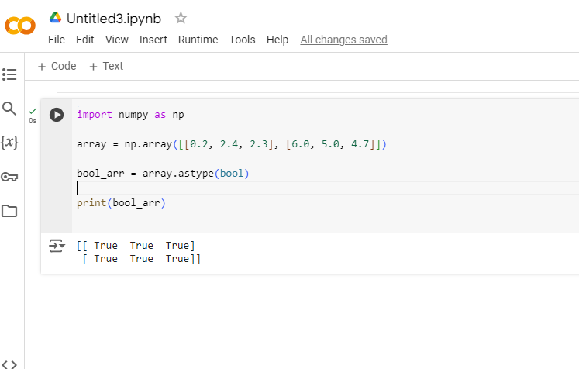

Task 2:

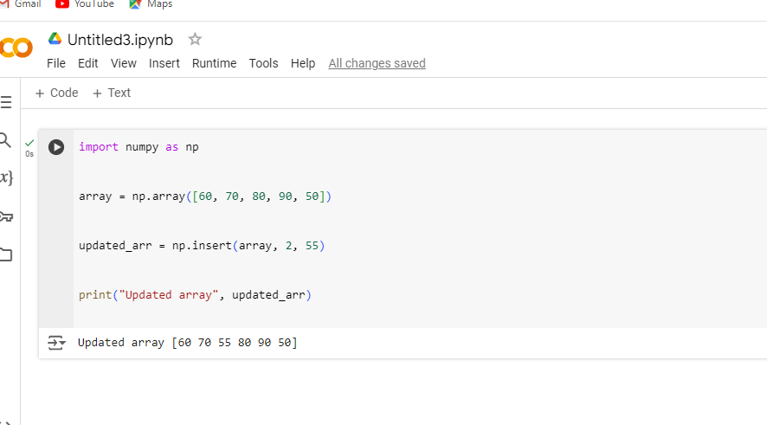

Task 3:

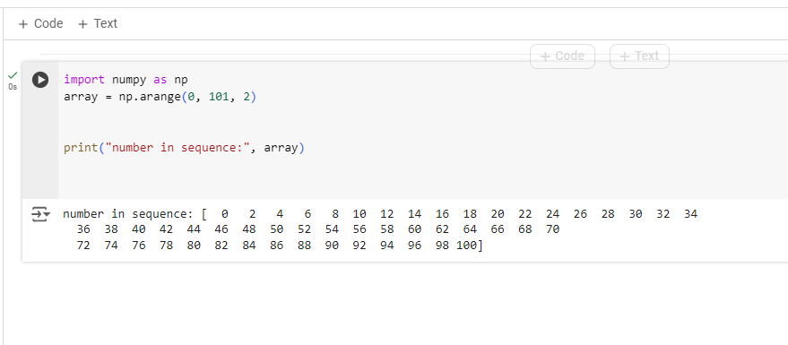

Task4:

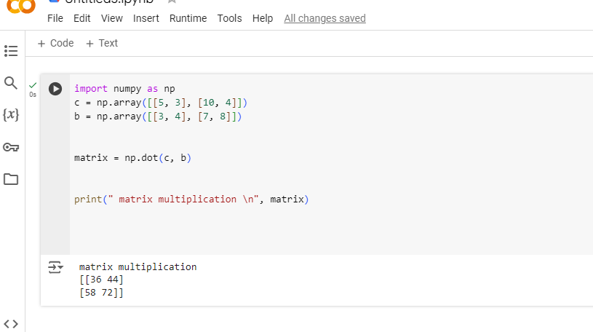

Task5:

